Inspiring Communities Together
Application Pack

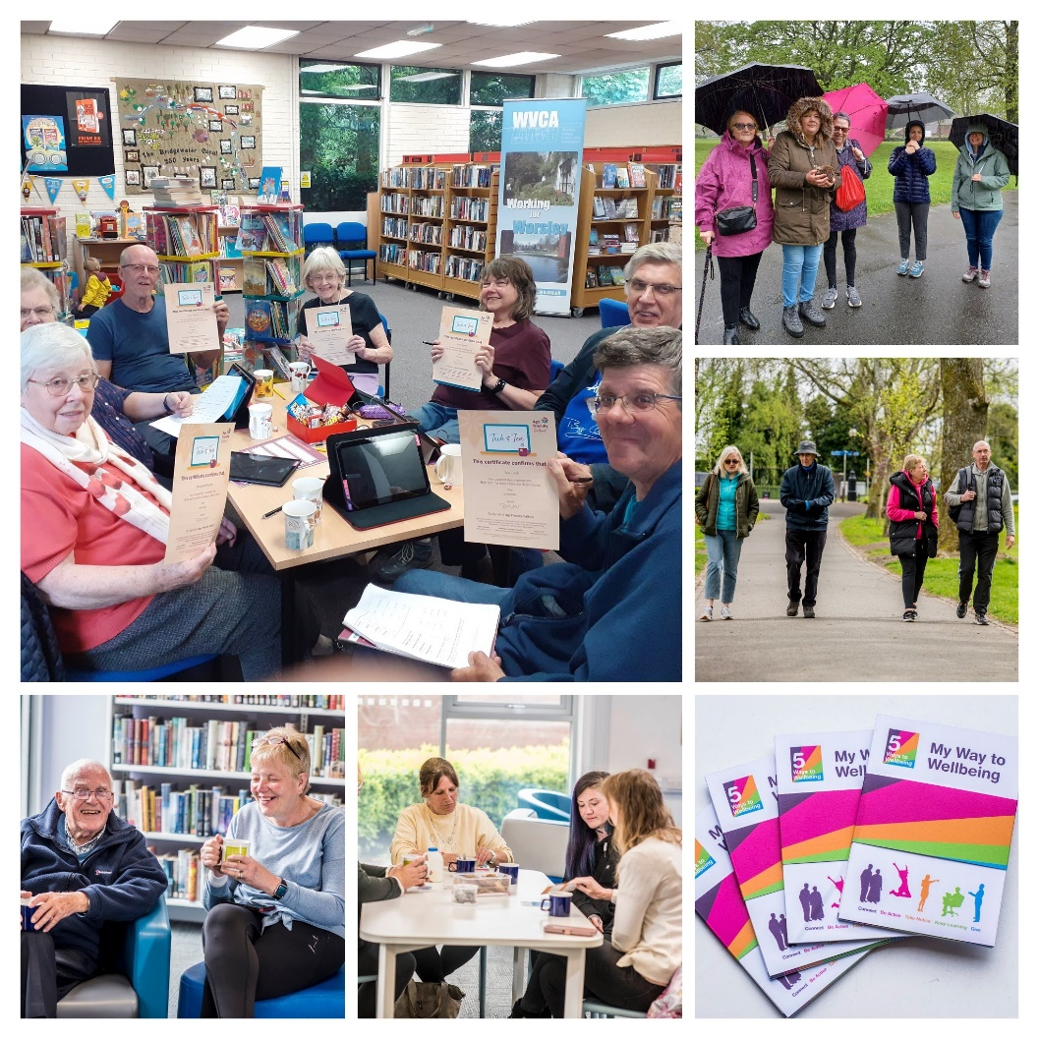

Age Friendly Salford
Development Worker (Digital Inclusion)
Fixed term contract to 31st December 2027

Closing Date: 6pm, Monday 25th May 2026
Interview Date: TBC

Introduction
Thank you for your interest in the role we are currently recruiting for. This Recruitment Application Pack has been designed to support you in preparing a strong and informed application. Alongside this introduction, the pack also includes the Job Description, Person Specification, Application Form and Equality Monitoring Form. Alongside this document, please also refer to the Recruitment Information Pack, which provides further details about working for Inspiring Communities Together.
To learn more about our organisation and the work we do, please visit our website: https://inspiringcommunitiestogether.co.uk/
Further information about the Age Friendly Salford programme can be found at: https://agefriendlysalford.org.uk/
We encourage all applicants to familiarise themselves with our work and values, as this will help you demonstrate how your skills and experience align with the needs of the role.

Information for Applicants
This pack provides guidance to help you complete the application process. If you require any support or encounter difficulties, please contact:
Tori Sparnenn, Age Friendly Salford Team Manager
Email: tori@inspiringcommunitiestogether.co.uk

How to apply:
All applications must be completed electronically and submitted by email.
We do not accept handwritten applications or CVs. Applicants must complete the official application form in full. Applications submitted only as CVs or without the required documents will not be considered.
Your application must include:
- Completed Application Form
- Equality Monitoring Form
- Contact details for two referees

Deadline:
Please submit your completed documents by 6pm, Monday 25th May 2026 to:
tori@inspiringcommunitiestogether.co.uk
Please include AFS development worker application in the email subject line.
Interview dates will be confirmed with shortlisted applicants.

Acknowledgement and Feedback
You will receive an email confirming receipt of your application. If you are not shortlisted for interview, you will be notified by email once the shortlisting process is complete. All interview invitations will also be sent via email.
Applicants who are not shortlisted may request feedback by email.
Applicants who attend an interview but are not selected may request feedback by email or by telephone at an agreed time.
Thank you again for your interest in joining Inspiring Communities Together. We wish you the best with your application.
Yours sincerely

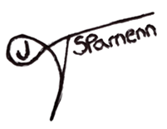

Tori J Sparnenn
Age Friendly Salford Team Manager

Job Description – Age Friendly Salford Development Worker

Job title: | Age Friendly Salford Development Worker (Digital Inclusion)
Team: | Age Well
Salary: | £17,122.56 per annum
Hours: | 24 hours per week
Duration: | Fixed term contract to 31st December 2027
Location: | This post will be offered on a blended working arrangement, working from the Innovation Forum and in the community across Salford (for which mileage will be paid)
Responsible to: | Age Friendly Salford Team Manager

Background
Age Friendly Salford is a programme of work funded by Salford City Council to deliver a collaborative approach to working across agencies and with older people ensuring the best outcomes for older people. We support residents of Salford to live healthy and active lives, reducing the risk of poor health as we age.

“Age Friendly” is about recognising the challenges of an ageing population and looking at all the different ways that together we can rise to those challenges, foster healthy and active ageing, make it possible for people to continue to stay in their homes participating in the activities they value and contributing to their communities for as long as possible.

Inspiring Communities Together, Age UK Salford and Trafford and Salford CVS have been working in partnership with older people and key partners since 2014 to develop and deliver an ageing in place model within neighbourhoods of Salford.

Job Overview
Working as part of the Age Well Team you will work alongside the AFS team manager to plan, deliver and monitor our digital inclusion activities across Salford, but will also support with the delivery of other activities as and when needed.

Main duties and responsibilities

Programme delivery
- Deliver digital inclusion activities, including Tech and Tea sessions in community settings and online (e.g. Zoom), as well as Digital Skills for Employment.
- Promote digital inclusion and the full range of Age Friendly Salford (AFS) activities to residents, volunteers and partners.
- Ensure all digital delivery aligns with AFS focus areas, including reducing loneliness, supporting active ageing, and enabling Voice & Influence where appropriate.
- Liaise with colleagues to source suitable community venues for delivery of digital inclusion sessions.
- Manage referrals into the Tech and Tea project and other digital inclusion activities.
- Complete registration processes and associated paperwork for all new learners, including taking payments for equipment where required.
- Set up tablets and other equipment in advance of sessions and manage stock in collaboration with the AFS Team Manager.
- Prepare and distribute certificates for learners.
- Provide signposting to internal activities and external services to further support digital inclusion and wellbeing.
- Support volunteers to deliver high quality digital inclusion sessions, providing direction, encouragement and safeguarding awareness

Partnership & Team Working
- Promote digital inclusion through effective partnership working with AFS Development Workers, the Age Well Team Manager, Programme Lead, and colleagues across partner organisations including ICT, Age UK Salford & Trafford and Salford CVS.
- Work collaboratively to deliver high-quality, neighbourhood-based digital inclusion and wellbeing activities.
- Represent the Age Well Team and digital inclusion programme at meetings, community events and relevant external forums as required.
- Contribute to strengthening partnerships that expand access to digital inclusion opportunities across the community.

Monitoring, Reporting & Quality Assurance
- Monitor and evaluate the impact of digital inclusion activities, ensuring accurate and timely recording of attendance, referrals, wellbeing conversations and outcomes using the CRM system.
- Complete before and after assessments for digital inclusion learners and conduct follow-up telephone questionnaires with a sample of participants.
- Produce personalised user journeys (case studies) demonstrating the impact of digital inclusion and contribute to quarterly monitoring reports.
- Support the development of improved outcome measurement for digital inclusion, including follow-up surveys and evaluation processes.
- Identify challenges, improvements and emerging themes from digital inclusion delivery to support continuous programme development.
- Ensure all monitoring and evaluation requirements are met in line with agreed timelines and reporting deadlines.

General Responsibilities
- Work flexibly, including occasional evenings and weekends with prior notice, to support digital inclusion activities and events.
- Undertake additional duties as reasonably required by the line manager or programme lead.
- Maintain high standards of professional conduct, including punctuality, presentation and administration.
- Comply with organisational policies and uphold the values of the organisation at all times.

Please note that because this job may involve working with young people and vulnerable adults, we will ask you to complete Enhanced DBS check. You must tell us in your application if you have any convictions, bind-overs or cautions, even if they are spent under the Rehabilitation of Offenders Act 1974. Please note that disclosing a conviction does not necessarily bar you from appointment.

Review arrangements
The details contained in this job description reflect the content of the job at the date it was prepared. It should be remembered, however, that it is inevitable that over time, the nature of individual jobs will change, existing duties may no longer be required and other duties may be gained without changing the general nature of the duties or the level of responsibility entailed. Consequently, the organisation will expect to revise this job description from time to time and will consult with the postholder at the appropriate time.

Date job description prepared/revised: | 6th May 2026
Prepared/revised by: | Tori J Sparnenn
Agreed job description signed by holder:

Personal Specification

Note to applicants:

Whilst all criterions below are important, those under the Essential heading are the key requirements. You should pay particular attention to these areas and provide evidence of meeting them. Failure to do so will mean that you will not be invited for interview.

Essential criteria
Experience & Knowledge
Experience of facilitating groups and delivering engaging, high-quality activities.
Experience of supporting people, building trust and holding wellbeing conversations.
Understanding of issues affecting older adults, including loneliness, frailty, digital exclusion and inequalities.
Understanding of VCSE values and community-based working.
Skills
Good, general IT competence (including setting up laptops/tablets, using smart phones, installing apps, trouble-shooting)
Excellent communication and interpersonal skills, able to work with people of different ages and backgrounds.
Strong IT literacy, including use of Microsoft Office, Teams, Zoom and CRM systems.
Ability to plan and organise workload, manage time and problem-solve effectively.
Ability to record information accurately and meet reporting deadlines.
Values & Behaviours
Ability to act with integrity, honesty, fairness and respect in all interactions.
Commitment to equality, diversity and inclusion and to promoting age-friendly principles.
Alignment with the values and ethos of the VCSE sector and Inspiring Communities Together.
Desirable criteria
Knowledge of the Five Ways to Wellbeing.
Level 3 Adult Education qualification.
Level 2 IAG qualification.
Experience supporting or directing volunteers.
Experience delivering activities to groups of older people.
Experience working in the voluntary and community sector.
Full driving licence with access to a car.
Local knowledge of Salford neighbourhoods.

Inspiring Communities Together –
Age Friendly Salford Development Worker (Social Participation)
Application Form

Closing date for completed applications is 6pm, Monday 25th May 2026

Name: | Address:
Telephone No: | Email Address:
What attracts you to apply for this position?

Please tell us about any previous experience(s) you have that you feel are relevant?

Have you undertaken any previous training that you feel is relevant?

Do you have any particular needs that we should be aware of so as to best support you?

Please give the names and addresses of two people who are willing to provide a reference on your behalf. One referee should be your line manager/ supervisor from a current or last employer or volunteering supervisor
Referee 1:
Name:  Address: | Relationship to you:
Name:  Address: | Email:
Referee 2:
Name:  Address: | Relationship to you:
Name:  Address: | Email:
Do you consider that you have a disability? (a physical or mental impairment which has a substantial and long-term effect on your ability to carry out normal day-to-day activities) |  | Yes | No
Applicants from suitably qualified disabled people are positively welcomed

Personal Specification

Whilst all criteria listed below are important, Essential criteria are in bold. It is important that you address these in detail. Where possible, please try and give examples of how you meet these criteria.

Experience & Knowledge
Experience of facilitating groups and delivering engaging, high-quality activities.
Experience of supporting people, building trust and holding wellbeing conversations.
Understanding of issues affecting older adults, including loneliness, frailty, digital exclusion and inequalities.
Understanding of VCSE values and community-based working.
Skills
Good, general IT competence (including setting up laptops/tablets, using smart phones, installing apps, trouble-shooting)
Excellent communication and interpersonal skills, able to work with people of different ages and backgrounds.
Strong IT literacy, including use of Microsoft Office, Teams, Zoom and CRM systems.
Ability to plan and organise workload, manage time and problem-solve effectively.
Ability to record information accurately and meet reporting deadlines.
Values & Behaviour
Ability to act with integrity, honesty, fairness and respect in all interactions.
Commitment to equality, diversity and inclusion and to promoting age-friendly principles.
Alignment with the values and ethos of the VCSE sector and Inspiring Communities Together.
Desirable Criteria
Knowledge of the Five Ways to Wellbeing.
Level 3 Adult Education qualification.
Level 2 IAG qualification.
Experience supporting or directing volunteers.
Experience delivering activities to groups of older people.
Experience working in the voluntary and community sector.
Full driving licence with access to a car.
Local knowledge of Salford neighbourhoods.

Declarations
Are you related to any of the following?
- An employee of the organisation
- A Trustee of the organisation
Yes |  | No
If yes please state their name and relationship to you:

Immigration, Asylum and Nationality Act 2006

Under the Immigration, Asylum and Nationality Act 2006, you are required to provide evidence of your right to work in the UK. If called for interview you will be advised of the documents you will need to provide which will then be checked to ensure the organisation complies with the current legislation.

If you have a national insurance number please write it here
Town of birth

Country of birth

I declare that the information give in this application form is accurate and that if it is subsequently discovered that any statement is false or misleading, my offer of employment may be withdrawn or I may be dismissed from my employment by the organisation without notice. I also agree to a medical examination if required.

If I am offered employment, I understand that it may be necessary for security and safeguarding purposes for Inspiring Communities Together to carry out a Disclosure and Barring check on any employees in positions which involve contact with vulnerable adults and children in the course of their work
Pleas tick here if have any objection to a DBS check being undertaken
I understand that for certain jobs, refusal may influence an offer of employment being made
signature |  | Date
If you are e mailing this form you will be asked to sign this application at interview

Applicants’ checklist
I have completed my declaration form
I have answered all the questions in person specification and given examples of how I meet the requirements
I have completed the equality monitoring form
I have given details of 2 referees

Inspiring Communities Together Equality Monitoring Form

At Inspiring Communities Together, we want to know that we are giving people equal opportunities throughout all aspects of our work. To ensure this happens we need to collect information from you. Please help us by answering the following questions

The information you provide will be used solely for monitoring purposes and will be treated as confidential

- I would describe my origin as (please tick as appropriate)

WHITE |  | MIXED BACKGROUND |  | ASIAN OR ASIAN BRITISH
English |  | White and Black Caribbean |  | Indian
Scottish |  | White and Black African |  | Pakistani
Welsh |  | White and Asian |  | Bangladeshi
Irish |  | Other mixed Background |  | Other Asian background
Other White background
BLACK OR BLACK BRITISH |  | CHINESE, CHINESE BRITISH OR OTHER ETHINIC GROUP
Caribbean |  | Chinese
African |  | Other background
Other Black background

2. | My gender is:
Male |  | □ | Female | □
Prefer to self-describe |  | □ | Prefer not to say | □

3. Please tick if you identify as LGBTQ+ □

4. Do you consider you have a disability? Yes No

5. Age: under 18 18-30 31-60 over 60

