Inspiring Communities Together
Application Pack

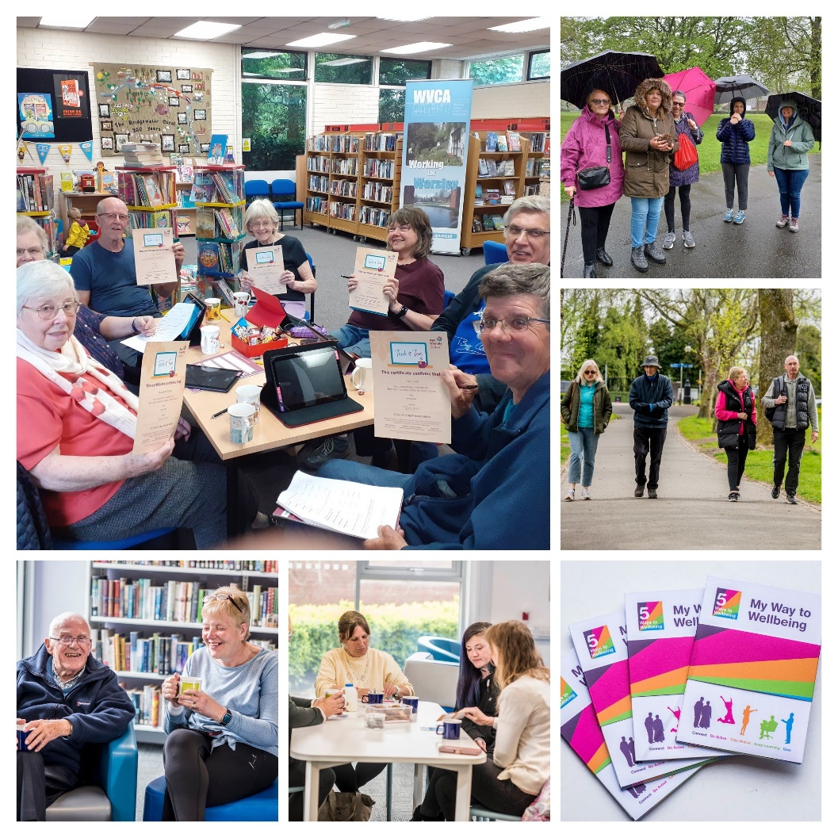

Living Well in Later Life Coordinator
Fixed term contract to 31st December 2028

Closing Date: 9am, Monday 30th March 2026
Interview Date: TBC

Introduction
Thank you for your interest in the role we are currently recruiting for. This Recruitment Application Pack has been designed to support you in preparing a strong and informed application. Alongside this introduction, the pack also includes the Job Description, Person Specification, Application Form and Equality Monitoring Form. Alongside this document, please also refer to the Recruitment Information Pack, which provides further details about working for Inspiring Communities Together.
To learn more about our organisation and the work we do, please visit our website: https://inspiringcommunitiestogether.co.uk/
Further information about the Age Friendly Salford programme can be found at: https://agefriendlysalford.org.uk/
We encourage all applicants to familiarise themselves with our work and values, as this will help you demonstrate how your skills and experience align with the needs of the role.

Information for Applicants
This pack provides guidance to help you complete the application process. If you require any support or encounter difficulties, please contact:
Antonia Dunn, Age Friendly Salford Programme Lead
Email: antonia@inspiringcommunitiestogether.co.uk

How to apply:
All applications must be completed electronically and submitted by email.
We do not accept handwritten applications or CVs. Applicants must complete the official application form in full. Applications submitted only as CVs or without the required documents will not be considered.
Your application must include:
- Completed Application Form
- Equality Monitoring Form
- Contact details for two referees

Deadline:
Please submit your completed documents by 9am, Monday 30th March 2026 to:
antonia@inspiringcommunitiestogether.co.uk
Please include Living Well in Later Life Coordinator application in the email subject line.
Interview dates will be confirmed with shortlisted applicants.

Acknowledgement and Feedback
You will receive an email confirming receipt of your application. If you are not shortlisted for interview, you will be notified by email once the shortlisting process is complete. All interview invitations will also be sent via email.
Applicants who are not shortlisted may request feedback by email.
Applicants who attend an interview but are not selected may request feedback by email or by telephone at an agreed time.

Thank you again for your interest in joining Inspiring Communities Together. We wish you the best with your application.
Yours sincerely


Antonia Dunn
Age Friendly Salford Programme Lead

Job Description – Coordinator (Living Well in Later Life)

Job title: | Coordinator (Living Well in Later Life)
Team: | Age Well
Salary: | £26,208 per annum
Hours: | 35 hours per week
Location: | This post will be offered on a blended working arrangement, working from the Innovation Forum, in the community across Salford (for which mileage will be paid) and at home.
Responsible to: | Programme Lead (Age Friendly Salford)

Job Overview

This is a new role within our rapidly expanding charity which will be responsibility for the delivery of an externally funding three year project within our wider Age Friendly Salford Team.

The Coordinator (Living Well in Later Life) plays a central role in delivering Salford’s contribution to the Greater Manchester Live Well in Later Life (LWLL) Programme, a multi-year, cross-sector initiative supporting healthier ageing, improving social connection, addressing inequalities and embedding age-inclusive practice across the city region.
The role incorporates strategic programme responsibilities, neighbourhood-based delivery and collaborative partnership working both locally and across GM.
The postholder will coordinate activity across targeted Salford neighbourhoods (Worsley & Boothstown; Weaste, Seedley & Langworthy; East Salford; Irlam and Cadishead) and engage older adults with intersecting vulnerabilities such as chronic loneliness, long-term health conditions, digital exclusion, unpaid caring or financial insecurity, in line with LWLL priorities.

The postholder will facilitate local partnerships, activate community-led solutions, support the development of age-friendly Live Well Centres and Spaces and ensure robust monitoring, reporting and knowledge-sharing across the Greater Manchester LWLL community.

As a member of the wider Age Friendly Salford Team the post holder will share learning from the project whilst linking with the overarching Age Friendly Salford programme and supporting the wider team as and when required to establish a city wide joined up approach to living well in later life.

Main Duties and Responsibilities
1. Programme Development, Coordination & Delivery
- Lead the delivery of Salford’s LWLL programme activity within target neighbourhoods, working across partners to deploy the LWLL blueprint and core tools.
- Carry out neighbourhood mapping and asset identification to understand how older residents use local places, identifying gaps that inform age-friendly improvements and community action planning
- Develop and implement place-specific engagement and participation plans using LWLL’s recommended approaches and engagement toolkit (e.g., 3 core questions, walking audits, community surveys).
- Engage and support older adults, particularly those experiencing social isolation, marginalisation or inequalities, to access social connection opportunities, Live Well offers and neighbourhood activities.
- Co-design and coordinate Action Plans with residents and partners, ensuring alignment with the WHO Age-Friendly domains and Salford’s Age Friendly Visions.
- Support the creation, use and sustainability of Age-Friendly Spaces and Live Well Centres, ensuring they provide accessible, inclusive support and social activity for older residents.

2. Micro-Grants and Community-Led Activity
- Manage Salford’s contribution to the LWLL micro-grants process, enabling community-led projects that promote social connection, sense of belonging and civic participation for older adults.
- Promote micro-grant opportunities, support applicants, convene decision processes and ensure monitoring and successful delivery of funded projects.
- Encourage and empower older residents to take active leadership roles in local projects and community solutions.

3. Partnership Working & Stakeholder Engagement
- Establish and facilitate local cross-sector relationships including VCSE groups, housing providers, neighbourhood teams, faith organisations, health partners and residents, strengthening the network of age-friendly support.
- Represent Inspiring Communities Together/Age Friendly Salford within GM LWLL forums, collaborative learning sessions and shared practice events.

- Contribute to local Live Well / Age Well reporting processes as required.
- Support efforts to involve older people in shaping local Live Well Centres, Spaces and Offers by helping to create opportunities for their voices and lived experience to inform design and development.

4. Monitoring, Reporting and Learning
- Produce high-quality programme monitoring, data returns, case studies, feedback summaries and evaluation inputs in line with the 6-monthly GM reporting schedule and internal ICT reporting cycles.
- Identify recommendations, lessons learned and future development opportunities to inform continuous improvement and funding bids.
- Contribute to shared GM learning and the dissemination of evidence, insights and promising practice across the LWLL network.

5. Human Resources
- This post has no line management responsibilities

6. General Responsibilities
- Deputise for the Programme Lead (Age Friendly Salford) when required
- Attend team meetings, supervision, training and development opportunities as required.
- Work flexibly, including occasional evenings and weekends, to meet programme needs and undertake, when required, other duties associated with supporting the needs of the organisation, which may be reasonably determined by the line manager and/or board of trustees
- Uphold ICT’s values, policies and high professional standards at all times.

Review arrangements
The details contained in this job description reflect the content of the job at the date it was prepared. It should be remembered, however, that it is inevitable that over time, the nature of individual jobs will change, existing duties may no longer be required and other duties may be gained without changing the general nature of the duties or the level of responsibility entailed. Consequently, the organisation will expect to revise this job description from time to time and will consult with the postholder at the appropriate time.

Date job description prepared/revised: | 25th February 2026
Prepared/revised by: | Antonia Dunn
Agreed job description signed by holder:
Personal Specification

Note to applicants:

Whilst all criterions below are important, those under the Essential heading are the key requirements. You should pay particular attention to these areas and provide evidence of meeting them. Failure to do so will mean that you will not be invited for interview.

Essential criteria
Experience & Knowledge
Proven experience in developing and delivering community projects and programmes
Experience designing and planning creative, engaging programmes that respond to local needs
Experience working across stakeholders to implement change, ideally within community or neighbourhood settings
Strong understanding of community engagement, participation approaches and partnership development, including with VCSE organisations, housing, primary care and local services.
Understanding of issues affecting older adults, including inequalities related to living alone, health, digital exclusion, caring responsibilities or economic insecurity.
Skills
Strong planning, coordination and project management abilities, able to balance strategic and operational responsibilities.
Excellent written and verbal communication, with the ability to adapt to a wide range of audiences including older residents, partners and strategic stakeholders.
Good numeracy and IT skills, including proficient use of Microsoft Office and data reporting tools.
Ability to prioritise a heavy and varied workload, meet deadlines and work effectively under pressure.
Values & Behaviours
Ability to act with integrity, honesty, fairness and respect in all interactions.
Commitment to equality, diversity and inclusion and to promoting age-friendly principles.
Alignment with the values and ethos of the VCSE sector and Inspiring Communities Together.
Desirable criteria
Project management qualification or training (e.g., Prince2, Agile).
Experience using social media and digital tools to promote opportunities or engagement activity.
Full clean driving licence and access to a vehicle for work purposes.
Local knowledge of Worsley & Boothstown; Weaste, Seedley & Langworthy; East Salford; Irlam and Cadishead.

Inspiring Communities Together –
Living Well in Later Life Coordinator
Application Form

Closing date for completed applications is 9am, Monday 30th March 2026

Name: | Address:
Telephone No: | Email Address:
What attracts you to apply for this position?

Please tell us about any previous experience(s) you have that you feel are relevant?

Have you undertaken any previous training that you feel is relevant?

Do you have any particular needs that we should be aware of so as to best support you?

Please give the names and addresses of two people who are willing to provide a reference on your behalf. One referee should be your line manager/ supervisor from a current or last employer or volunteering supervisor
Referee 1:
Name:  Address: | Relationship to you:
Name:  Address: | Email:
Referee 2:
Name:  Address: | Relationship to you:
Name:  Address: | Email:
Do you consider that you have a disability? (a physical or mental impairment which has a substantial and long-term effect on your ability to carry out normal day-to-day activities) |  | Yes | No
Applicants from suitably qualified disabled people are positively welcomed

Personal Specification

Whilst all criteria listed below are important, Essential criteria are in bold. It is important that you address these in detail. Where possible, please try and give examples of how you meet these criteria.

Experience & Knowledge
Proven experience in developing and delivering community projects and programmes
Experience designing and planning creative, engaging programmes that respond to local needs
Experience working across stakeholders to implement change, ideally within community or neighbourhood settings
Strong understanding of community engagement, participation approaches and partnership development, including with VCSE organisations, housing, primary care and local services.
Skills
Strong planning, coordination and project management abilities, able to balance strategic and operational responsibilities.
Excellent written and verbal communication, with the ability to adapt to a wide range of audiences including older residents, partners and strategic stakeholders.
Good numeracy and IT skills, including proficient use of Microsoft Office and data reporting tools.
Ability to prioritise a heavy and varied workload, meet deadlines and work effectively under pressure.
Values & Behaviour
Ability to act with integrity, honesty, fairness and respect in all interactions.
Commitment to equality, diversity and inclusion and to promoting age-friendly principles.
Alignment with the values and ethos of the VCSE sector and Inspiring Communities Together.
Desirable Criteria
Project management qualification or training (e.g., Prince2, Agile).
Experience using social media and digital tools to promote opportunities or engagement activity.
Full clean driving licence and access to a vehicle for work purposes.
Local knowledge of Worsley & Boothstown; Weaste, Seedley & Langworthy; East Salford; Irlam and Cadishead.

Declarations
Are you related to any of the following?
- An employee of the organisation
- A Trustee of the organisation
Yes |  | No
If yes please state their name and relationship to you:

Immigration, Asylum and Nationality Act 2006

Under the Immigration, Asylum and Nationality Act 2006, you are required to provide evidence of your right to work in the UK. If called for interview you will be advised of the documents you will need to provide which will then be checked to ensure the organisation complies with the current legislation.

If you have a national insurance number please write it here
Town of birth

Country of birth

I declare that the information give in this application form is accurate and that if it is subsequently discovered that any statement is false or misleading, my offer of employment may be withdrawn or I may be dismissed from my employment by the organisation without notice. I also agree to a medical examination if required.

If I am offered employment, I understand that it may be necessary for security and safeguarding purposes for Inspiring Communities Together to carry out a Disclosure and Barring check on any employees in positions which involve contact with vulnerable adults and children in the course of their work
Pleas tick here if have any objection to a DBS check being undertaken
I understand that for certain jobs, refusal may influence an offer of employment being made
signature |  | Date
If you are e mailing this form you will be asked to sign this application at interview

Applicants’ checklist
I have completed my declaration form
I have answered all the questions in person specification and given examples of how I meet the requirements
I have completed the equality monitoring form
I have given details of 2 referees

Inspiring Communities Together Equality Monitoring Form

At Inspiring Communities Together, we want to know that we are giving people equal opportunities throughout all aspects of our work. To ensure this happens we need to collect information from you. Please help us by answering the following questions

The information you provide will be used solely for monitoring purposes and will be treated as confidential

- I would describe my origin as (please tick as appropriate)

WHITE |  | MIXED BACKGROUND |  | ASIAN OR ASIAN BRITISH
English |  | White and Black Caribbean |  | Indian
Scottish |  | White and Black African |  | Pakistani
Welsh |  | White and Asian |  | Bangladeshi
Irish |  | Other mixed Background |  | Other Asian background
Other White background
BLACK OR BLACK BRITISH |  | CHINESE, CHINESE BRITISH OR OTHER ETHINIC GROUP
Caribbean |  | Chinese
African |  | Other background
Other Black background

2. | My gender is:
Male |  | □ | Female | □
Prefer to self-describe |  | □ | Prefer not to say | □

3. Please tick if you identify as LGBTQ+ □

4. Do you consider you have a disability? Yes No

5. Age: under 18 18-30 31-60 over 60

