**Inspiring Communities Together**

**Application Pack**

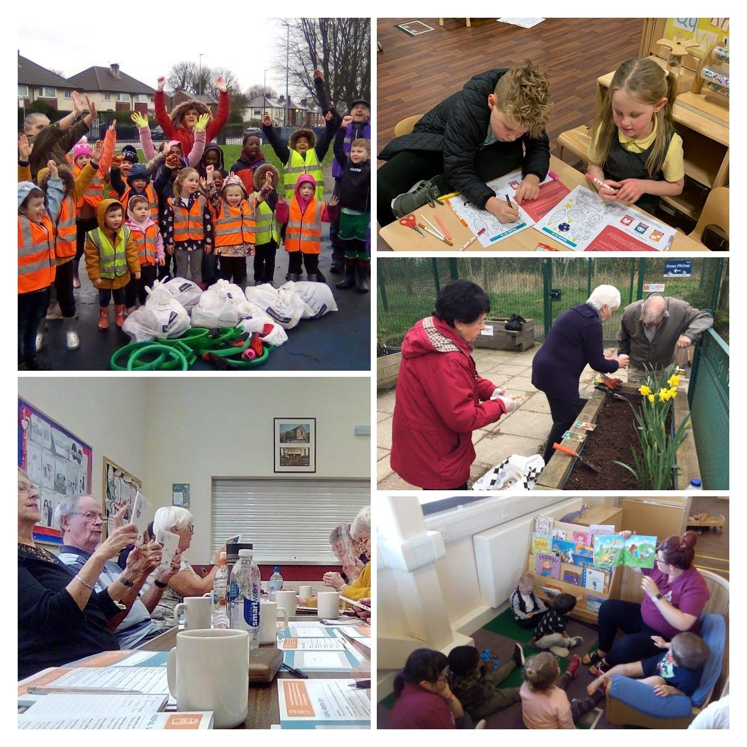

**Sessional Play Workers**

**(Children and Families)**

Closing Date: open recruitment

Interview Date: TBC

**Message from the Chair**

Inspiring Communities Together has come a long way since it became a Charity in 2014 and has ambitious plans to build on the good work already achieved to take the Charity forward over the next period of its development.

This role requires a variety of skills and knowledge and a determination to make things work. You will need to have a passion for children and families and have a positive attitude even when things are not going well

You will be welcomed into a friendly environment where your personal and professional development will be encouraged. You will have the opportunity to work and grow in a people-centred and values-based organisation that promotes a positive permission culture.

Your work-life balance and wellbeing are important to us so you will have access to a range of benefits including:

|  |
| --- |
| * Living wage Employer * Funded DBS Check and claim back of annual update service fee * Paid sick leave – subject to terms and conditions of service * Comprehensive In house E Learning * 26 day leave entitlement (additional day per year after five years up to five days) plus 8 Bank Holidays * 35 hour working week for all full time staff * Health and Wellbeing Programme – including access to 24/7 counselling and support line * Free Onsite Parking |

Thank you for your interest in Inspiring Communities Together and we look forward to receiving your application.

Yours sincerely



Mike Duddy

Chair

**Message from the CEO**

# Thank you for considering applying for the role advertised. This pack has been created to help you learn more about Inspiring Communities Together and ensure that you complete a good quality application.

Inspiring Communities Together is one of over 1,600 Community and Voluntary Sector Organisations delivering programmes of work in Salford. We are not the oldest Charity but do have a rich history

**About our work**

Our program of work is delivered across three core themes each overseen by a program manager:

**Children and Families** – We offer a programme of family support activities aimed at providing information, advice and support to parents and carers to help them give their children the best start in life and maintain their own good health and wellbeing. Alongside this holistic work we also provide a full wrap around Ofsted registered child care provision

**People** & **Place** - We deliver learning that enables people to develop skills, knowledge and confidence, improving health and well-being and promote the wider benefits of learning. We offer a program of activities which focus on building resilient neighbourhoods where individuals value themselves, where they live and their local neighbourhood public green and blue spaces

**Ageing Well** – We aim to *achieve positive outcomes for older people to ensure they can age well and look after their own health and wellbeing*. This work is delivered in Partnership with Age UK Salford and Salford CVS. We deliver a range of activities and support in the community and via the telephone and virtually

Our model of working aims to deliver quality of life improvements across the core areas of Start Well, Live Well and Age Well. Our approach has shifted slightly from our previous approach and now recognises the overlap between the three core areas:

If you feel this role is right for you we look forward to hearing from you.

Bernadette Elder

CEO

**Information for applicants**

# In this pack we have provided you with information and guidance to help you through the application process but should you have any difficulties please do not hesitate to contact Carol Hyde (Programme Manager – Children and Families) via email on [childcare@inpiringcommunitietogether.co.uk](mailto:childcare@inpiringcommunitietogether.co.uk)

All applications must be submitted by email and completed electronically. No handwritten applications will be accepted.

**About you**

We are looking for people who are passionate about improving the lives of local Salford people. We are seeking motivated and passionate Play Worker/s to join our team on an ‘as and when’ basis, covering the school holiday period. The ideal candidate will be someone who loves working with children.

**Equality and Diversity**

We are committed to developing a culture which respects individuals, appreciates difference and allows everyone regardless of background to reach their full potential. We understand how hard it can be to combine caring for a loved one with work, so

we aim to provide support and flexibility to balance family and caring responsibilities with work.

**Top tips**

* Please complete the application form provided – make sure you answer all the questions
* Ensure you provide enough details about your experience and knowledge to carry out the role
* Check your application before sending

**Acknowledgement and feedback**

You will receive an email acknowledgement of your completed application. Invitations to interview will be sent via email.

All unsuccessful applicants are welcome to ask for feedback on the reasons for not being shortlisted or selected at interview stage. Feedback for not being shortlisted will only be given by email.

Feedback following non-selection at interview stage can be given by email or telephone at an agreed time.

Successful applicants are required to become members of Inspiring Communities Together.

Please return you completed documents to [childcare@inspiringcommunitiestogether.co.uk](mailto:childcare@inspiringcommunitiestogether.co.uk) using the reference **SPW** in the subject header.

**Interview date to be confirm**

**Job Description – Sessional Play Worker**

|  |  |
| --- | --- |
| **Job title:** | Sessional Play Worker |
| **Team:** | Children and Families |
| **Salary:** | £ 12.38 per hour |
| **Hours:** | Flexible  (9.00am – 5.00pm Monday to Friday – school holidays only) |
| **Location:** | Yogurt Pots Child Care, Sports Village, Littleton Road, Salford |
| **Responsible to:** | Programme Manager (Children and Families) |

**Responsible for:** no line management responsibility

**Job Overview**

Provide access to play activities for children aged 5 years – 11 years of age (last year of primary school). Assist the childcare team in providing a caring, safe, stimulating environment for children to explore, grow, inspire, have fun and meet their full potential. To comply with all H&S, Safeguarding, OFSTED legislation and requirements

**Main duties and responsibilities**

**Operational and compliance**

The post holder will be expected to:

* Work with the wider Children and Families Team to create a safe, welcoming and inclusive environment for all children
* Provide a safe, caring and stimulating environment of children, including those with Special Educational needs.
* Work within the framework set by Ofsted to ensure requirements are met
* Promote and foster a working environment in which the psychological, physical, developmental and educational well-being of children is paramount
* Work as part of the staff team to develop programmes which meet the needs and aspirations of the children attending the setting
* Ensure that a supportive, empathic and non-judgemental approach is used by all staff and volunteers when interacting with children and their families
* Identify resources required to deliver a good quality children and families programme
* Signpost family members to wider organisational opportunities and external opportunities including learning and volunteering opportunities and information, advice and guidance support as appropriate
* Contribute to the development and delivery of initiatives to improve efficient and effectiveness of the service including new ideas to improve standards

**Other**

* To work as part of the children and families team to achieve the wider organisational objectives
* To attend team meetings, supervision sessions and any external meetings as required
* To work flexibly and undertake, when required, other duties associated with supporting the needs of the organisation, which may be reasonably determined by the line manager and/or Senior Management Team
* To work flexibly and attend occasional meetings and events outside normal working hours (evenings and weekends) for which notice will be given
* To undertake training and professional development as and when required
* Ensure high levels of professional conduct including punctuality, dress, presentation and administration
* Comply with the policies of Inspiring Communities Together at all times

###### Please note if this job involves working with young people and vulnerable adults, we will ask you to complete Enhanced DBS check. You must tell us in your application if you have any convictions, bind-overs or cautions, even if they are spent under the Rehabilitation of Offenders Act 1974. Please note that disclosing a conviction does not necessarily bar you from appointment.

|  |
| --- |
| Review arrangements |
| The details contained in this job description reflect the content of the job at the date it was prepared. It should be remembered, however, that it is inevitable that over time, the nature of individual jobs will change, existing duties may no longer be required and other duties may be gained without changing the general nature of the duties or the level of responsibility entailed. Consequently, the organisation will expect to revise this job description from time to time and will consult with the postholder at the appropriate time. |

|  |  |
| --- | --- |
| Date job description prepared/revised: | 3 July 2024 |
| Prepared/revised by: | Bernadette Elder |
| **Agreed job description signed by holder:** |  |

**Personal Specification**

**Note to applicants:**

Whilst all criterions below are important, those under the **Essential** heading are the key requirements. You should pay particular attention to these areas and provide evidence of meeting them. Failure to do so will mean that you will not be invited for interview.

**Essential Criteria**

|  |  |  |
| --- | --- | --- |
|  | **Necessary requirements – skills, knowledge, experience etc.** | **Assessment** |
| **E** | Educated to Level 2 qualification in Play Work,or Childcare (or equivalent) |  |
| **E** | Ability to support and monitor staff and students |  |
| **E** | Paediatric first aid qualification (if not in possession of this, must be achieved as part of induction) |  |
| **E** | Knowledge of legislation relevant to Early Years such as EYFS 21, SEN, safeguarding, Childcare Act 2006 |  |
| **E** | Knowledge of Child Development and children’s needs, including additional support needs |  |
| **E** | Ability to work with parents/carers/families to encourage partnership working |  |
| **E** | Ability to communicate well with adults and children |  |
| **E** | Ability to work as part of a team |  |

**Desirable Criteria**

|  |  |
| --- | --- |
| **D** | Experience in working with early years/primary school children in a paid or voluntary capacity |
| **D** | Good IT skills including using Word, Excel and PowerPoint |
| **D** | Food Hygiene Level 2 (if not in possession of this, must be achieved as part of induction) |
| **D** | Knowledge of online reporting systems such as Tapestry |
| **D** | Experience using social media to promote events and opportunities |
| **D** | Local resident of Charlestown and/or Lower Kersal |
| **D** | Extensive knowledge of Charlestown and/or Lower Kersal |
| **D** | Full clean driving licence with access to a car |

|  |  |
| --- | --- |
| **Personal qualities** | |
|  | Ability to act honestly, reasonably and with integrity |
|  | Active commitment to equality and diversity |
|  | Commitment to promoting the core values of the organisation |

**Inspiring Communities Together**

**Sessional Play Worker**

**Children and Families**

**Application Form**

|  |
| --- |
| **Open application process** |

|  |  |  |  |
| --- | --- | --- | --- |
| **Name:** | **Address:** | | |
| **Telephone No:** | **Email Address:** | | |
| **What attracts you to apply for this position?** | | | |
| **Please tell us about any previous experience(s) you have that you feel are relevant?** | | | |
| **Have you undertaken any previous training that you feel is relevant?** |  | | |
| **Do you have any particular needs that we should be aware of so as to best support you?** |  | | |
| **Please give the names and addresses of two people who are willing to provide a reference on your behalf. One referee should be your line manager/ supervisor from a current or last employer or volunteering supervisor** | | | |
| **Referee 1:** | | | |
| **Name:**  **Address:** | **Relationship to you:** | | |
| **Email:** | | |
| **Referee 2:** | | | |
| **Name:**  **Address:** | **Relationship to you:** | | |
| **Email:** | | |
| **Do you consider that you have a disability? (a physical or mental impairment which has a substantial and long-term effect on your ability to carry out normal day-to-day activities)** | | **Yes** | **No** |
| ***Applicants from suitably qualified disabled people are positively welcomed*** | | | |